**Year 1 Knowledge Organiser: Spring 1**



**Religion and World Views**

This unit introduces some core shared Jewish and Christian beliefs about the creation of the world. The unit also considers the special relationship between God and his people.

**Art**

We will begin to further explore mark making. We will create a sculpture by folding and twisting paper and gluing onto a base. Photography of shadow and light.

**Geography**

Our geography topic this half term is Where We Are. This topic is an introduction to locating our local area in the UK; identifying the four countries of the UK; some key human and physical features

**Science**

In this topic we will be looking at everyday materials. We will be exploring how to distinguish objects from their material, and describing simple properties.

**Reading**

The class author focus for Year 1, is Vashti Harrison. We are currently reading several of her texts in our class read aloud, such as Hello Star and Cece loves science. Our daily Phonics reading sessions focus on reading the sounds we already know, reading fluently and developing our comprehension. At the end of the day during our class read alouds this is where we focus on voice choice.

**PHSE**

The children will be looking at what we need to stay healthy. Regarding our diet but also how our mind can be.

**PE**

PE will be every Tuesday with Mr Wood, please ensure your child is bringing in the correct PE kit. They will be focusing on invasion groups.

**Music**

This half term we will continue using charanga, our unit is ‘In the groove’. Children will be practicing and performing the song In The Groove by Joanna Mangona.

**Maths**

This half term we will be consolidating our knowledge of our number bonds to 6. We will also focus on place value within 20 and addition and subtraction within 20. After we have done these 2 units we will begin looking at place value within 50

**Writing**

**Writing to entertain** – We will be creating our own story based on the stick or other object have collected.

**Writing to inform** – Children will apply their learning to creating their own informative texts about themselves or another topic of their choice.

**Writing to entertain –** The children will create their own poems and comic scenes using the shared texts as inspiration.

**How to help at home…**

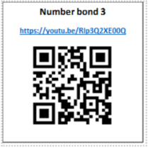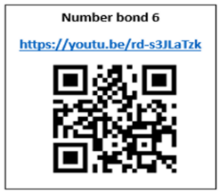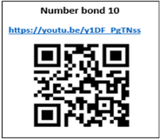**

**Geography**

In order to support your child in geography this half term, you could go on a walk and get your child to identify the human and physical features they see, identify plants and animals they see in their local area and identify and draw the map of the UK labelling correctly too.

**Science**

In order to support your child in science this half term, you can visit this website

<https://www.stem.org.uk/resources/community/collection/12725/year-1-everyday-materials>

There are quizzies and different activities to work through.

**Maths**

Please ensure that your child is practicing their number bonds at home, we practice these in class everyday, your extra support at home will secure this knowledge further. You can also watch the videos below by using the QR codes, which will help you to understand how we teach number bonds at school.

**Writing**

To help your child remember sentences that they create, why not have a go at some memory games at home? Choose a few items from around the house and place them on a tray. Allow your child time to look at the items, then cover them up. How many of the items can your child remember and name?

**Reading**

You can support your child at home by ensuring that you are reading with them daily and logging their reading on learningwithparents.com through either a comment, picture, or voice recording! At school we have lots of books that your child can borrow and take home, these can be exchanged as many times as you would like!